CULTURE: Not your normal fleet week
6 May 2019
Gabrielle Lipton and Ming Chun Tang

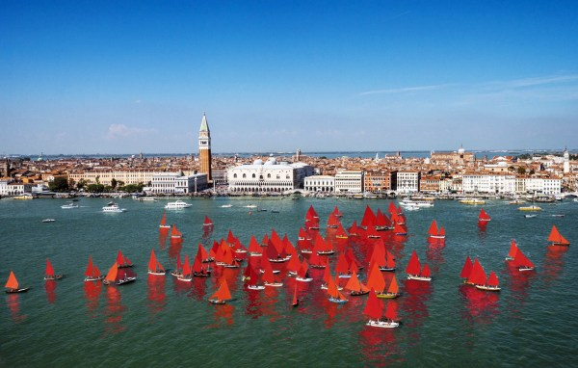
A rendition of artist Melissa McGill’s Red Regatta art installation that will soon open in Venice’s waters. Melissa McGill

Bill McKibben speaks on an NPR podcast on how the predictions of climate change he made 30 years ago in The End of Nature– regarded as the first book on the topic – are now coming true. His new book Falter goes more in-depth into what climate change could look like.
Another new release, Melinda Gates’ The Moment of Lift: How Empowering Women Changes the World, takes a gendered approach to sustainable development through tales from her work and travels with the Bill & Melinda Gates Foundation.
And in Italy’s sinking city, artist Melissa McGill is a making climate change an inescapable red-alert with 52 vela al terzo sailboats filling Venice’s waters with red sails until November.

